Our group’s app is called Lucre (an archaic word for money and profit). The app is built to be an expense managing app that quickly and efficiently store daily expenses and income, giving the user a daily budget based on a monthly period of income.

**Main Page, Daily Activity Screen** (all the bold words in this report are the titles of windows with their own images within the report)

As seen, this will be the **main page** of the app given that a user has signed into his/her profile (otherwise a login/create account screen will show instead). The user adds **expenses or income** by pressing the + button at the bottom of the screen. The expenses or income are then added to the daily overview, calculated towards the daily budget. Past days are able to be seen by scrolling down, and expense and income can be added to them. The month and year is chosen by selecting from the top drop down text. At the very top is an overview section that will give the current monthly report that will always update. The monthly overview includes the income, expense, and savings of the current month. Clicking on the overview screen will show the **overview report window** built around giving the user a succinct report for the month, aided with visuals.

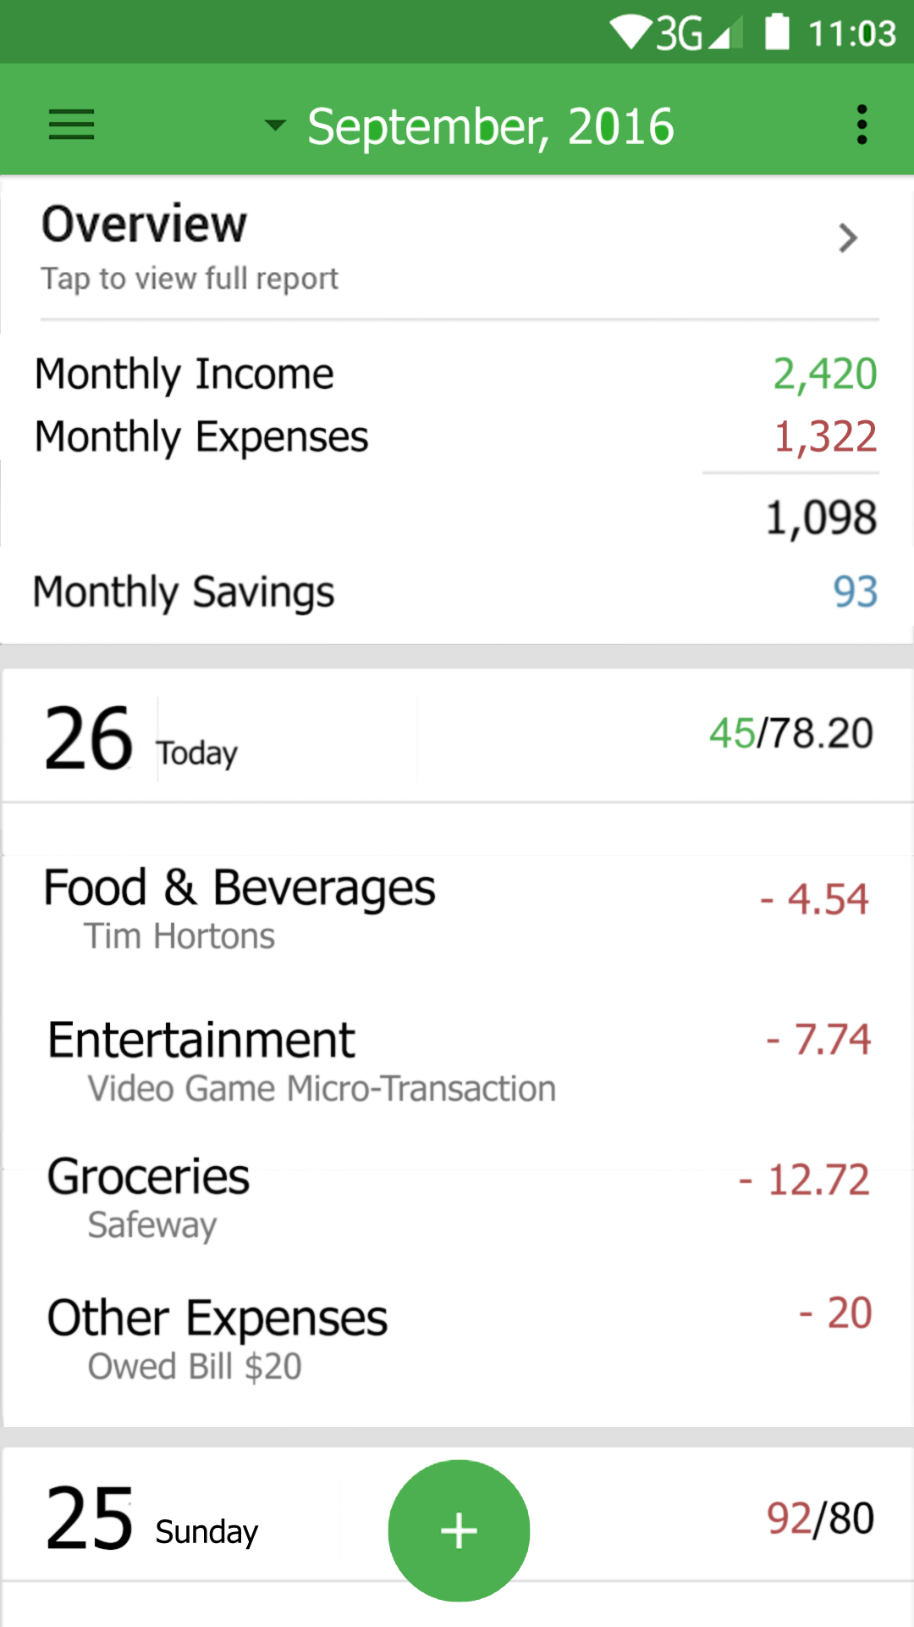

If the user goes over the daily budget, the expenses are cut from the income and a new daily budget is given. This is seen when the user in this scenario goes over his budget on the 25th. The budget total turns red and the 26th’s budget is adjusted. The app also allows the user to input categorical budgets that will allow the user to see how much he/she is spending in what every day and every month. The allotment of expenses each month will also be saved and later displayed in graphs given in the **overview** screen.

The **overview** **screen** gives an overview report for the selected month. The first section will show the total income, expense, savings for that month, along with the total user’s savings.

**Overview Screen**

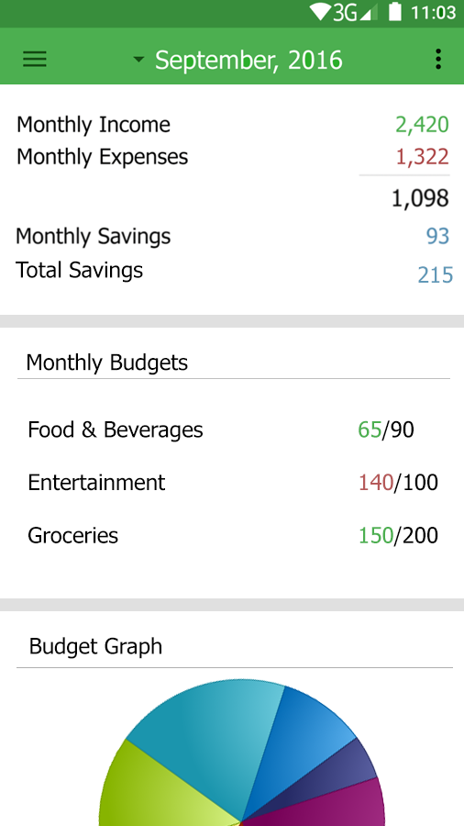

The monthly budgets section will show how much money the user has spent on categorical expenses that the user will create (some categories come suggested) for the current month. The monthly budgets section is so that the user can see how much money he/she is spending in a single category so he/she can adjust their spending patterns if need be.

The budgets are also used to show graphs of where the user’s money is being spent and how much.

(\***EDIT**\*): There will be a new section in the **overview screen** that will show the total amount of money in all the user’s accounts, along with his/her total savings. And THEN there will be section showing monthly income and expense, as well as monthly savings as shown already.

**Income and Expense popup windows**

(occurs on top of the current **Daily Expense** window)

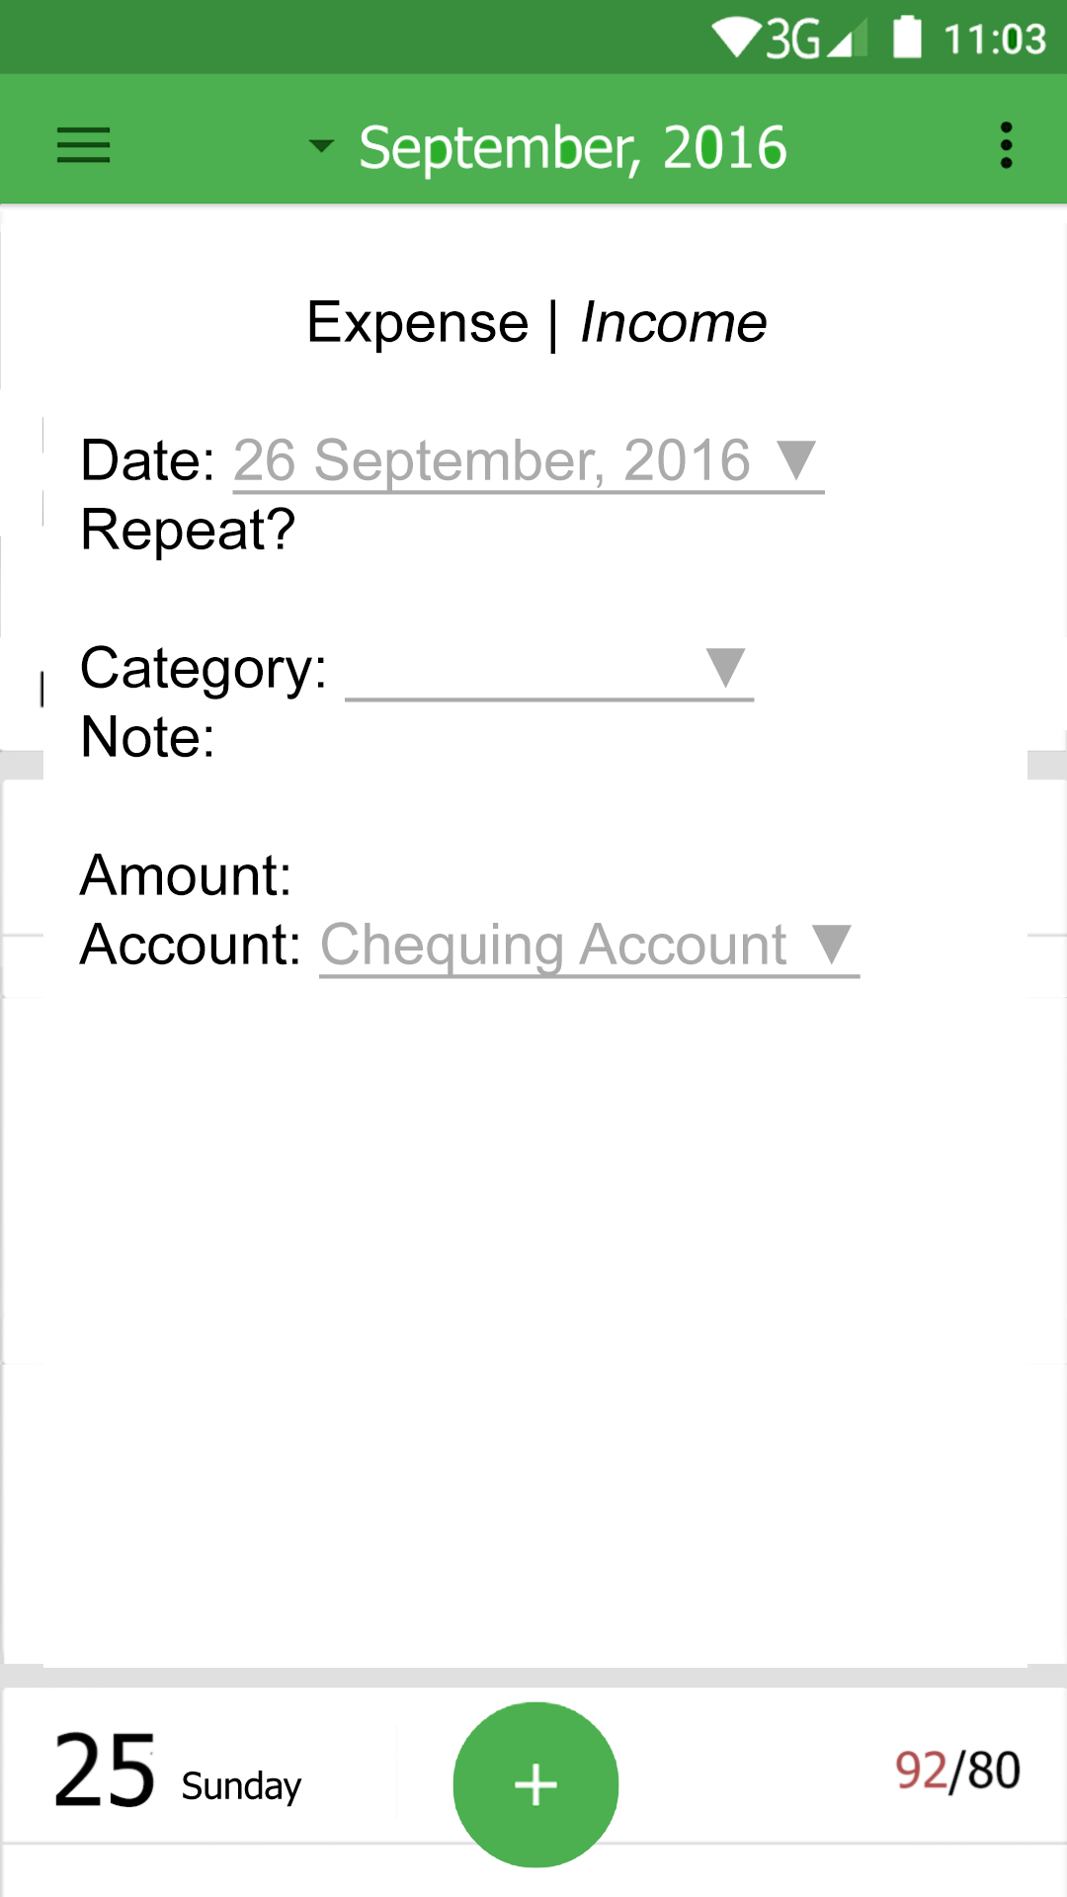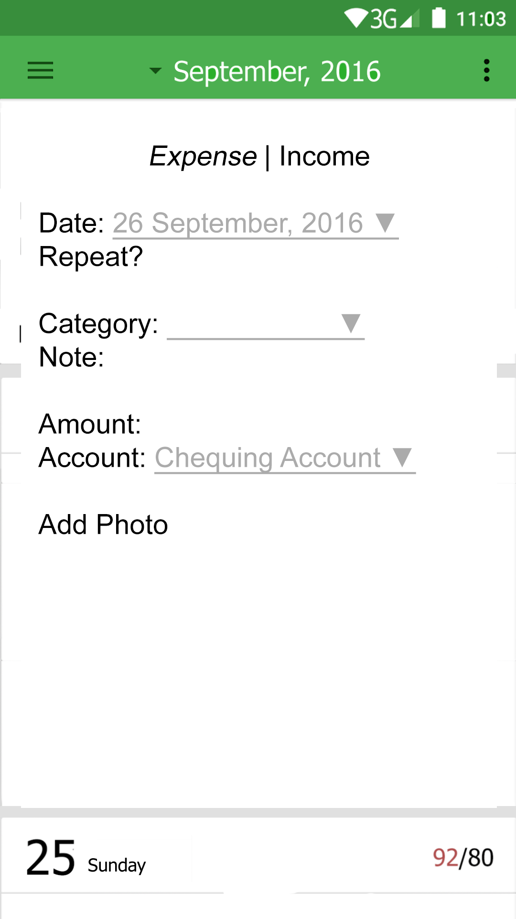

**Menu Screen**

The **expense and income windows** pop up after the + button is pressed by the user on the **Daily Activity**screen. This window will allow the user to input an expense or income depending on the tab he/she selects at the very top of the popup window. The user will be able to select a date, including a previous date. By default, the selected date will be the current one. The user will also be able to select whether or not the expense repeats, taking him to the **Bill** Screen. Next, the user will be allowed to set the expense/income’s category and note. And finally its amount and account—Under accounts, the user can select **SAVINGS** and the expense will be subtracted from his/her calculated savings. Under expense, the user can upload a photo tied to a specific expense. This is so that the user can take a picture of a receipt for future reference.

**Menu Screen**

The **menu screen** (displayed after clicking on the top left menu button) allows the user to navigate to different screens in the app. The Daily Activity label will take the user to the **Daily Activity** screen, and Overview label will provide a fast shortcut to the **overview screen.** After these two, there are the Budget and Savings labels, and then finally the Bills and Income labels.

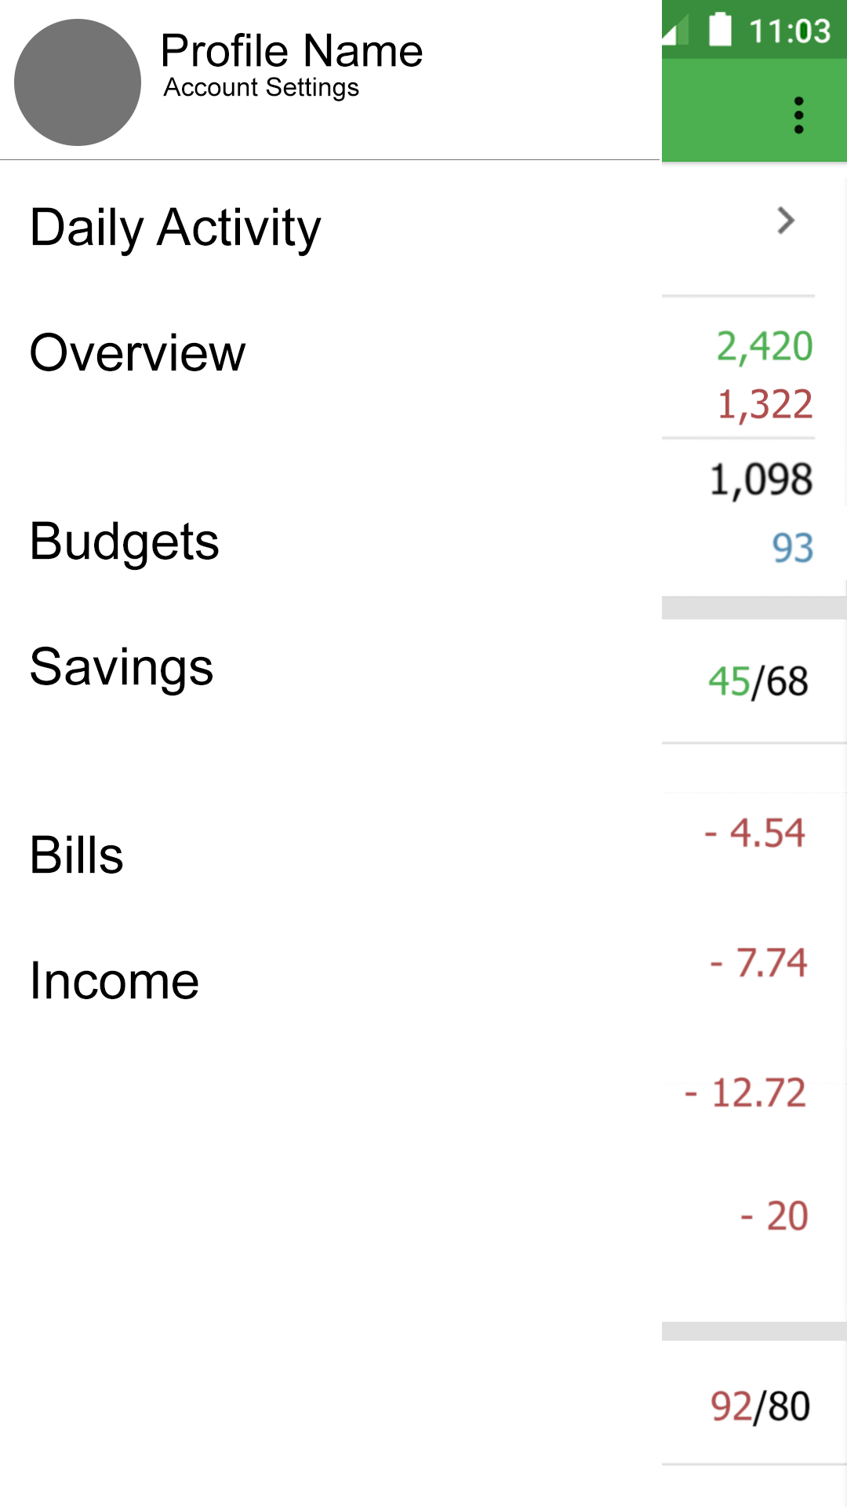

Clicking on the profile name will take the user to an account settings page where he/she will be able to edit his name, password, email address, and profile picture.

The **Budget** screen allows the user to set monthly budgets. The budgets add as expenditure categories. Going over the budget will result in a notification and, if the user allows, an e-mail warning the user that he has gone over his budget.

**Savings Screen**

**Budget Screen**

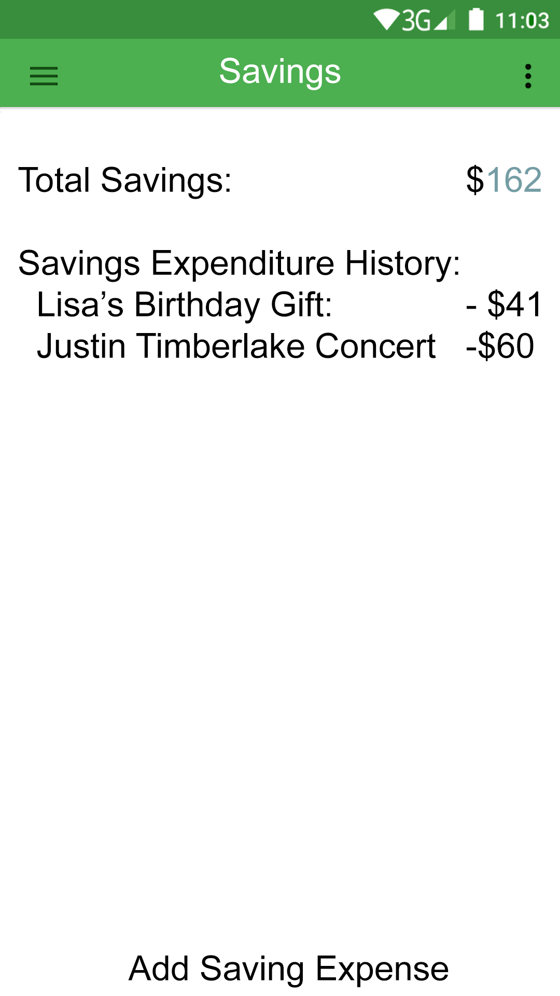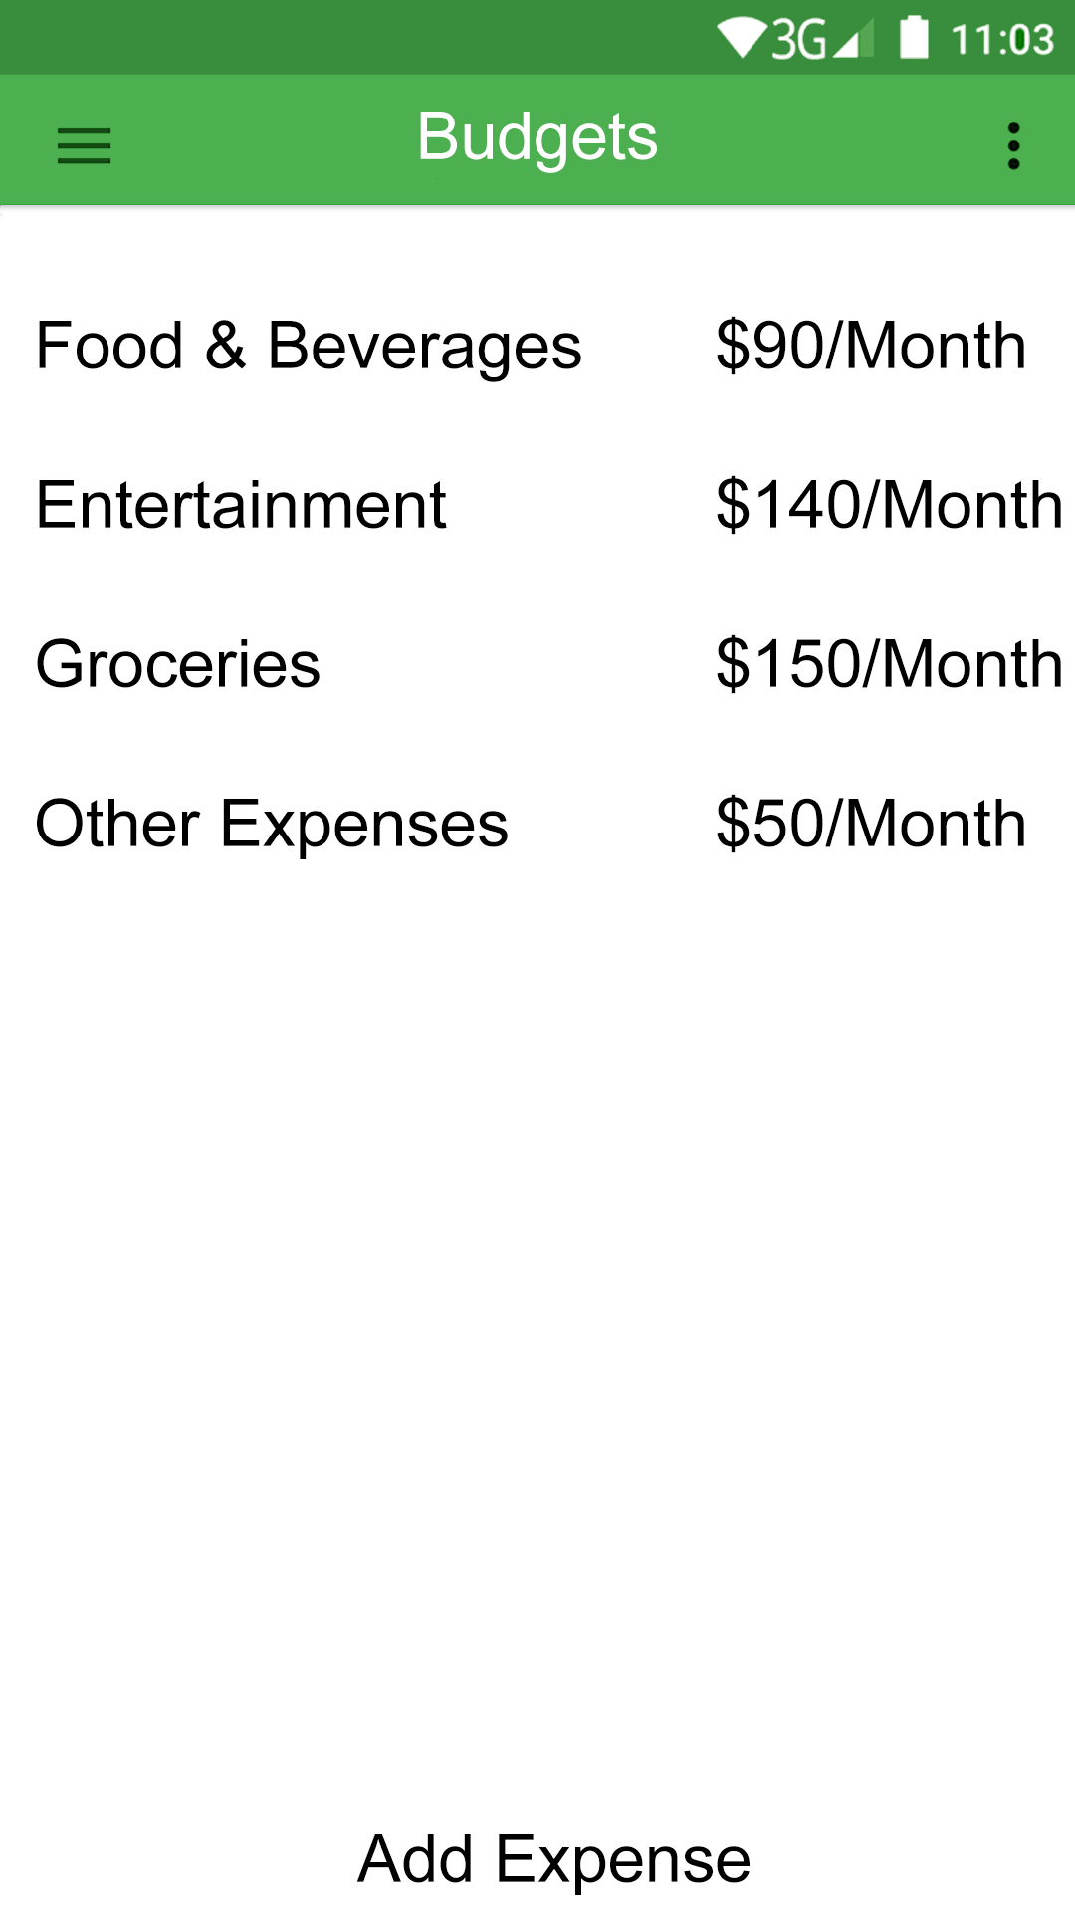

The **Savings** screen shows the total savings amount for the user. This screen also displays saving expenditures so he/she can keep track of when the last time they used their savings.

The **Bills** screen allows the user to add monthly expenditures that occur on a certain date or dates each month. Bills will automatically be added to the daily activity screen and automatically take from the user’s account.

**Bills Screen**

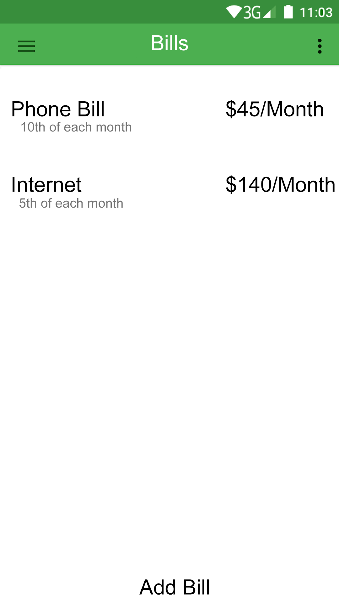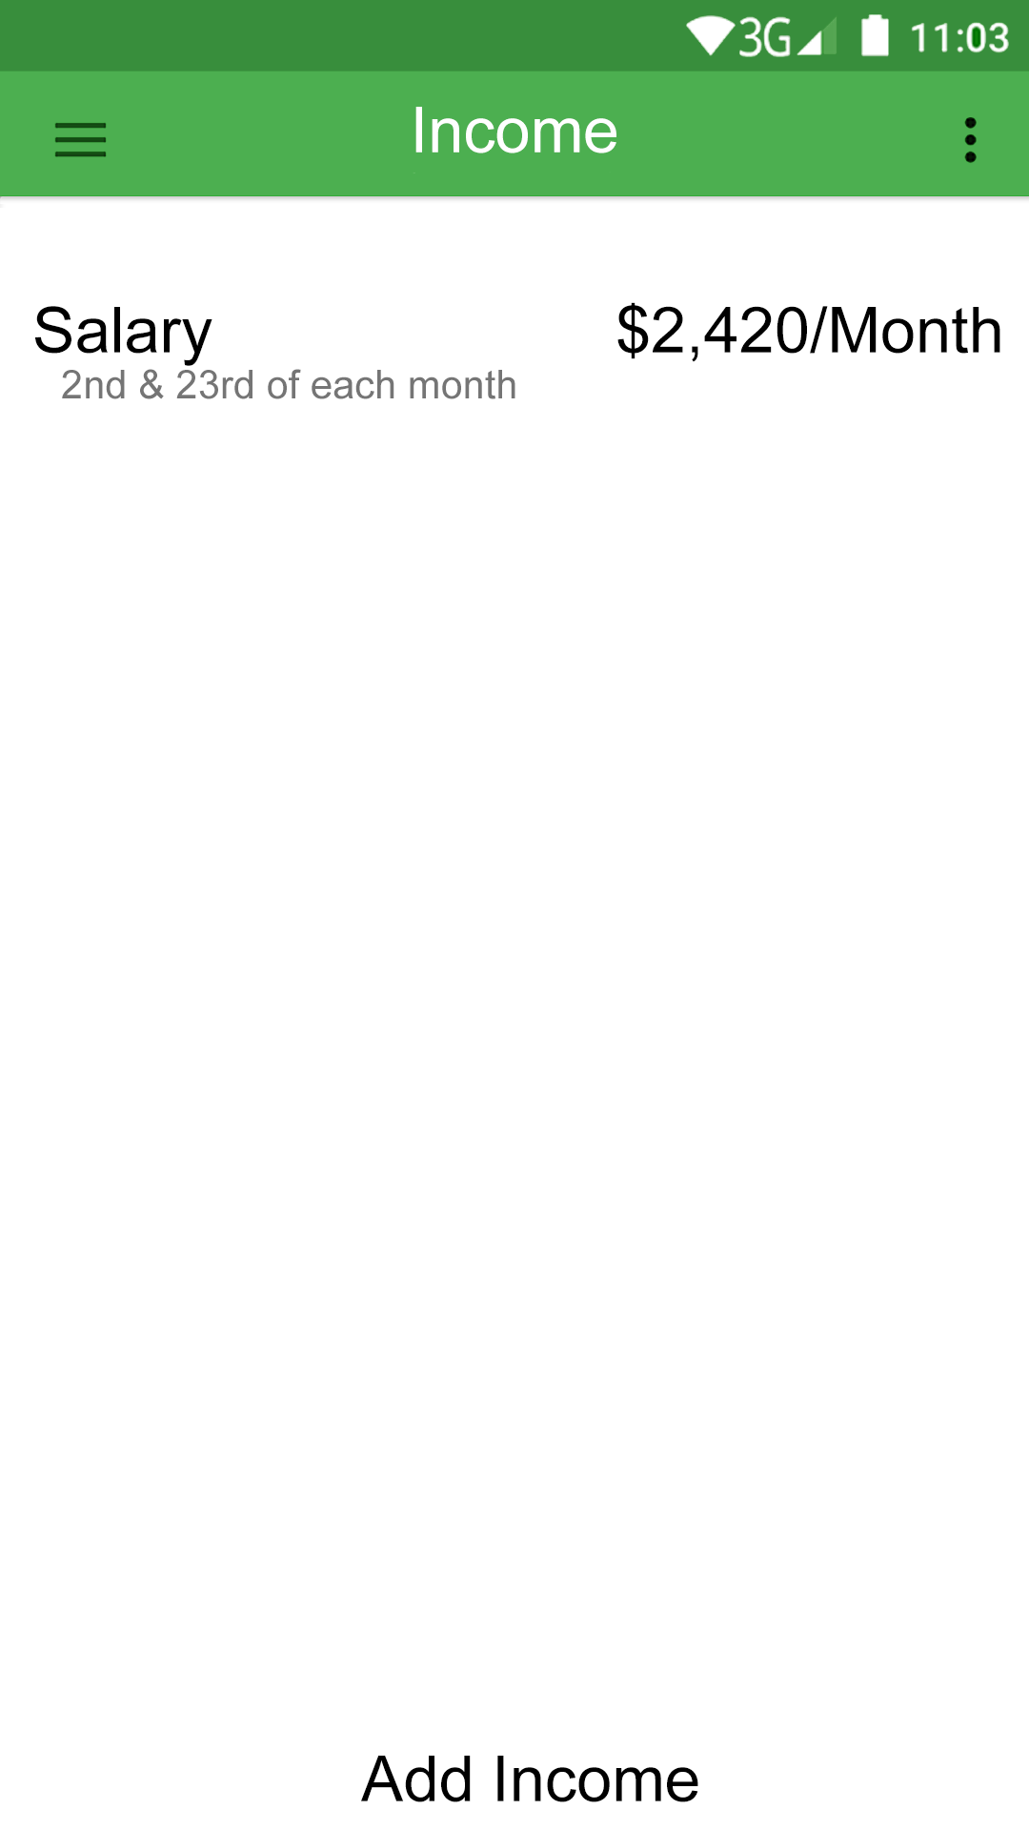

**Income Screen**

The **Income** screen allows the user to add income dates as many times a month for recurring income. The app may, instead of working on a month-to-month basis starting from the first of each month, work on a month-to-month basis starting on the earliest income of each income each month, and last 30~ days. (If the user gets payed on the 2nd and 23rd, the “month” will start on the 2nd, and end on the 1st of the next month). This way, the user can accurately calculate his expenditures and balance them with his/her income. Otherwise, a month could start and the user will be in the negative for a several days of the month until he/she finally gets payed. And even then, the expenditures will be offbalanced with the income. Setting the user’s month would be achievable on the **Income** screen, or the **daily activity** screen by clicking on the three dot settings right of the month.